Name: ____________________________________ Class: _____________



JURONG PIONEER JUNIOR COLLEGE
JC2 Preliminary Examination 2024

GEOGRAPHY 8834/01

Higher 1 10 September 2024

Paper 1 3 hours

INSERT

READ THESE INSTRUCTIONS FIRST
This insert contains all the Resources referred to in the questions.

This document consists of 8 printed pages.
[Turn over
[Turn over
[Turn over
Resources 1A and 1B for Question 1

Resource 1A

Location of the five survey sites in Ang Mo Kio

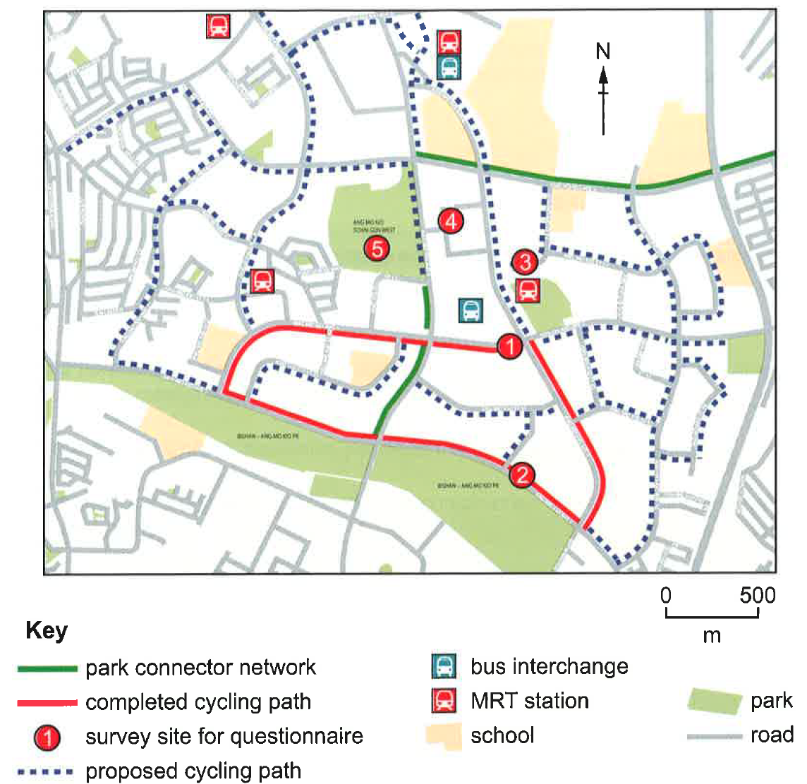

Resource 1B

Information about the five survey sites in Ang Mo Kio

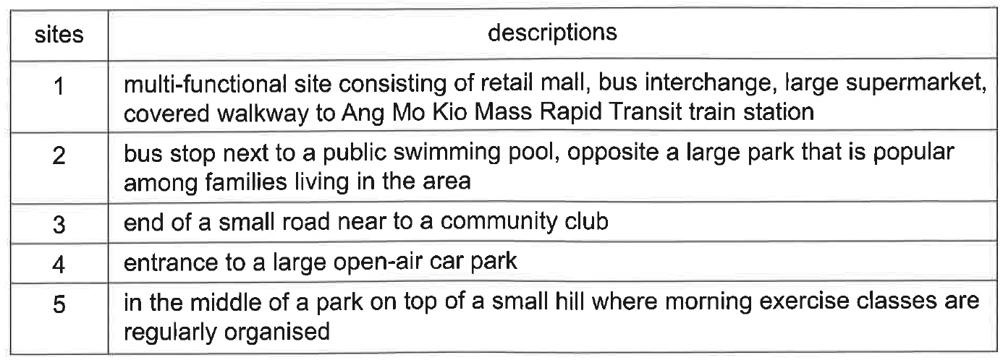

Resource 2 for Question 1

Survey site 1 in Ang Mo Kio

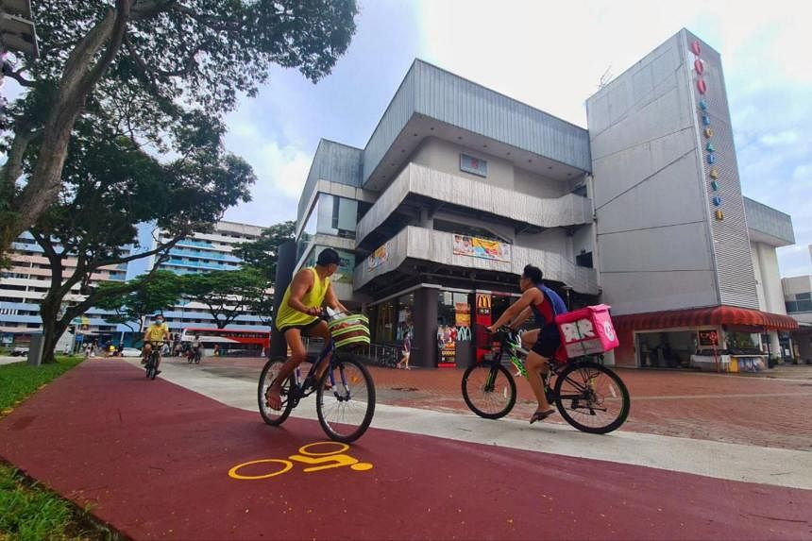

Resource 3 for Question 1

Questionnaire for the survey

Gender: Male / Female Age (circle) : Below 15 15-64 Above 65

Please choose one option:

SA – Strongly Agree N-Neutral SD – Strongly Disagree

 | Cycling Infrastructure | SA | N | SD
1 | Cycling paths are well constructed
2 | Slopes and ramps are provided
3 | The provided cycling paths have encouraged me to cycle

 | Safety | SA | N | SD
4 | I do not feel safe using the cycling path
5 | Pathways are crowded / blocked due to high number of cyclists

 | Cost | SA | N | SD
6 | I am willing to pay the cost of a good standard of bicycle
7 | Using a bicycle is the cheapest way to travel

 | Time | SA | N | SD
8 | Cycling does save a lot of time
9 | I am willing to travel further when cycling

 | User-friendliness | SA | N | SD
10 | Cycling paths are inconvenient to use
11 | I am more likely to cycle if there are more cycling paths and facilities

 | Eco-friendliness | SA | N | SD
12 | Reducing my carbon footprint is important to me when choosing my mode of transport
13 | I believe cycling is eco-friendly than other modes of transportation
14 | I am willing to switch from other modes of transportation to cycling if the environmental benefits were clearly demonstrated

Resource 4 for Question 1

Selected results from the survey

Question No. | Factor | Number of respondents who indicated the factor as:
Question No. | Factor | Strongly Agree | Neutral | Strongly Disagree
3 | Provided cycling paths have encouraged me to cycle | 137 | 33 | 30
12 | Reduce carbon footprint is important to me | 78 | 50 | 72
14 | Willingness to switch to cycling if environmental benefits were clearly demonstrated | 157 | 25 | 18

Resource 5 for Question 2

Percentage of the total population that lives in urban areas for selected world regions from 1990 to 2050 (projected)

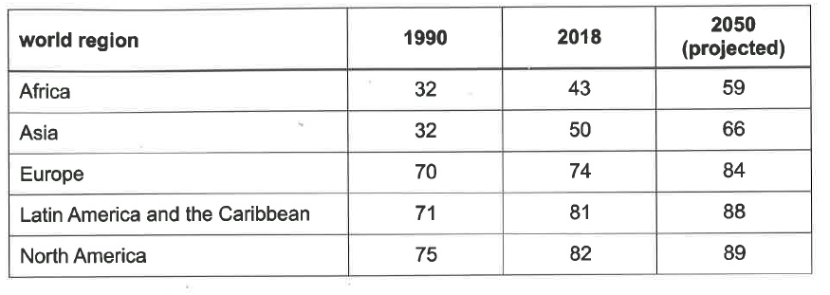

Resources 6A and 6B for Question 2

Resource 6A

Ecological footprints of Athens, Greece, and Cairo, Egypt

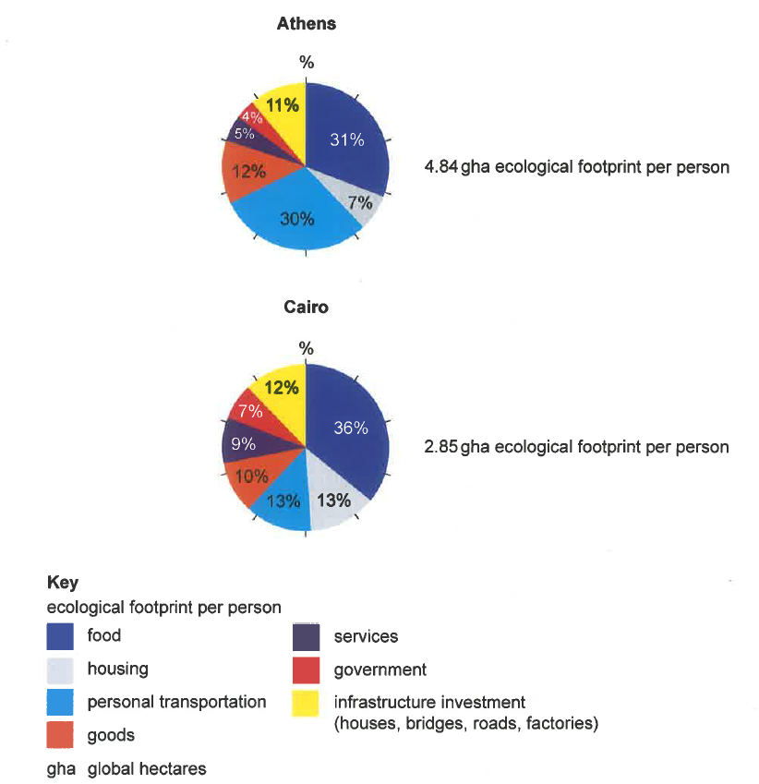

Resource 6B

Biocapacity* data for Greece and Egypt

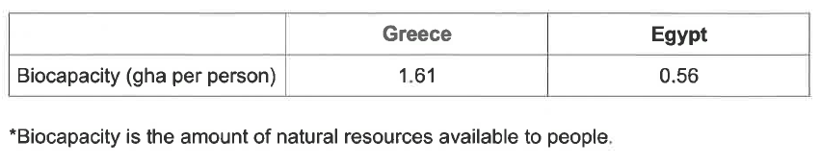

Resource 7 for Question 2

Athens’ Urban Sustainability Achievements between 2015-2023

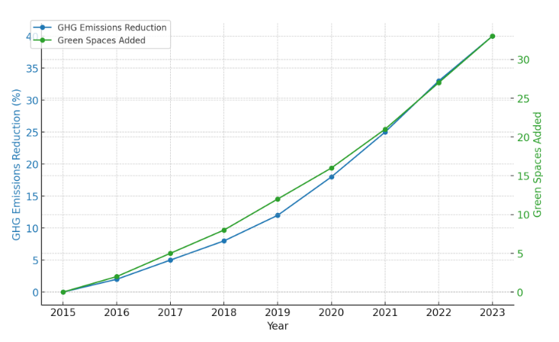

*GHG means greenhouse gas

Resource 8 for Question 3

Contributions of selected greenhouse gases to global warming since 1850

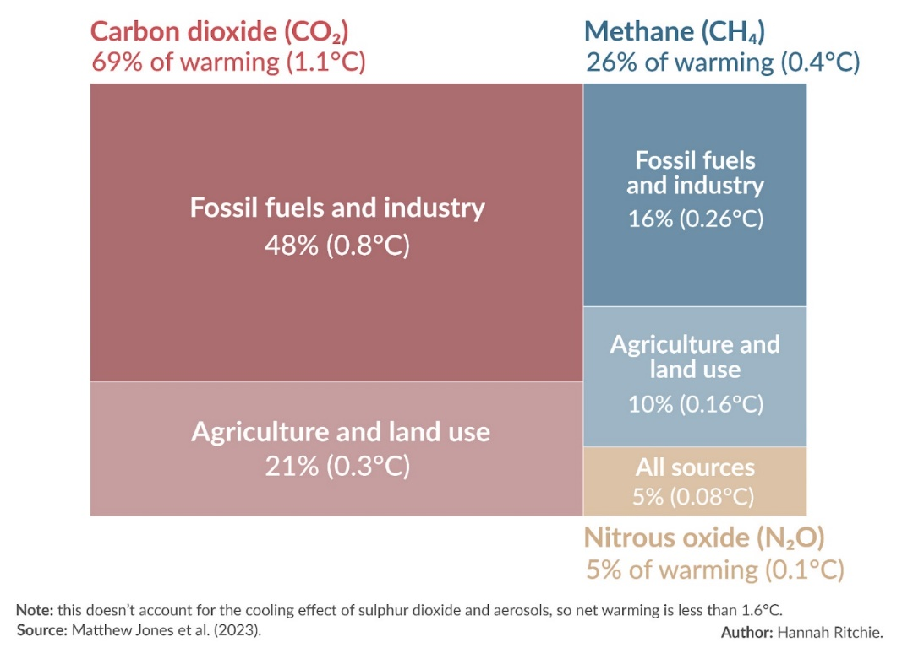

Resource 9 for Question 3

Projected impacts of climate change for selected continents (millions of people) by 2080

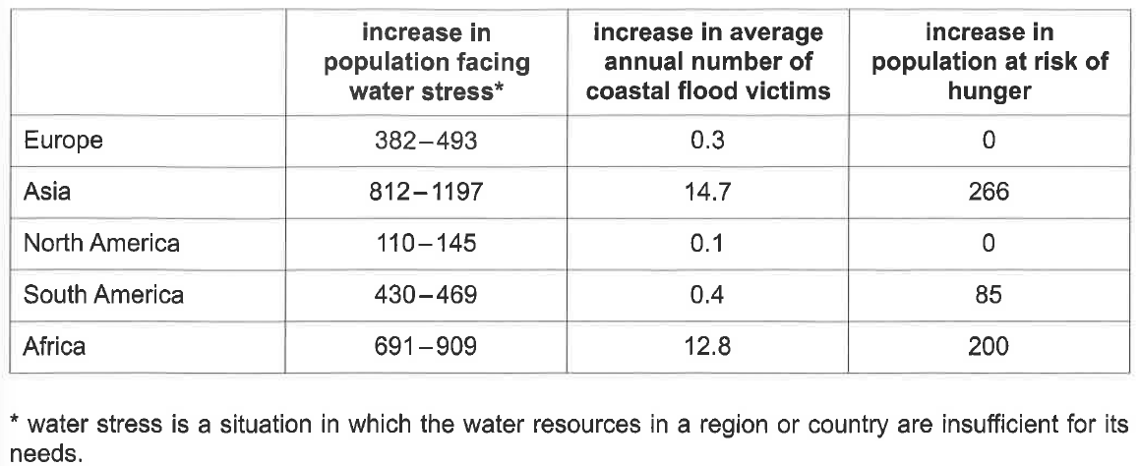

End

